**PROJECT REPORT**

**Introduction:**

The health-care system should be aim to provide best and fastest mode of medical attention to the people throughout the country while optimizing for cost and time efficiency. Medical help dose not often reach the people in need, particularly in developing countries like India due to the huge population and a large number of rural areas far away from good hospitals. The current healthcare system causes distress and adverse scenarios in rural areas where people are need of first attention. The incapability of the current medical services represents a problem for the healthcare system and produces an unnecessary burden on many families of India. Our proposed project introduces a system which will provide fastest delivery of medical facility in the rural areas such as blood, vaccines, defibrillator, and antivenins. These resources are used in emergency, basically in rural as well as urban areas.

**Technical Requirement:**

Our modules such as:

**Software: (Mission Planer)**

This allows you to prepare, plan and monitor your various missions. In our project we connect Drone to mission planner software for getting the information of exact location of our drone, it helps to find the altitude, bandwidth frequency, speeds, angle, battery status, GPS status, etc. of drone. This software and drone are connected with the telemetry, which is used to retrieve flight information of drone on computer or radio control in order to follow several parameters of aircraft on the ground station (Centralized Hub).

**Hardware:**

**Brushless Motor:**

A brushless DC motor also known as electronically commuted motor and synchronous Dc motor. The features of this motor are high speed, electronic control and low maintenance.

**Propellers:**

We using a quad copter structure, it has four propellers, two “normal” propellers that spin counter-clockwise, and two “pusher” propellers that spin clockwise.

**ESC (Electronic Speed Controller):**

The ESC is an electronic circuit that controls and regulates the speed of electric motor. It generating three high frequency signals with different but controllable phases continually to keep the motor turning.

**Flight Controller:**

The flight controller is the brain of any quadcopter which consist of, built in Gyroscope, Accelerometer sensors. Flight controllers are continuously evolving with their processors becoming faster to keep up with evolving flight controller software’s.

**G-Module:**

A GPS tracking unit is a navigation device normally carried by a moving vehicle or person or animal that uses the Global Positioning System (GPS)to track the device’s movements and determine its location. Waypoint GPS Navigation allows a drone to fly on its own with its flying destination or points preplanner and configured into the drone remote control navigational software.

**Transmitter & Receiver:**

A radio control system is made up of two elements, the transmitter you hold in your hands and the receiver you put inside your drone, once the receiver has this information it passes it on to your drone’s flight controller which makes the drone move accordingly. The transmitter is an electronic device that uses radio signals to transmit commands wirelessly via a set radio receiver. The radio receiver is the device capable of receiving commands from the transmitter.

**Battery:**

Lithium polymer (LiPo) batteries offer the best combination of energy density, it is used because of high energy density and high discharge rate. We typically use 3s1p batteries, which indicate 3 cells in parallel.

**Frame:**

The frame of a drone is the main part and the skeleton upon which the rest of component will be attached. The frame should be rigid and be able to minimize the vibrations coming from the motors. Every quad copter or other multi-rotor aircraft needs a frame to house all the other components

**Mobile Application:**

Whenever user wants emergency of blood or medicine instead of going hospital user can simply open an application and enter their request to UAV centralized server. The module which required to user that display on requirement list. User click on button it might be Blood or Medicine and fill all the details about patient. After selection module, the next step is to give the delivery address and pay for the module, if the user can go to order method so they can directly pay the amount through the online transaction method. If once payment gets successful order than it gets confirm message in their E-mail. After receiving the user request in a UAV centralized server and hospital they can immediately go ahead their UAV(Drone) to deliver the product. As soon as order get safely delivered to the destination the UAV centralized server and user can get the message.

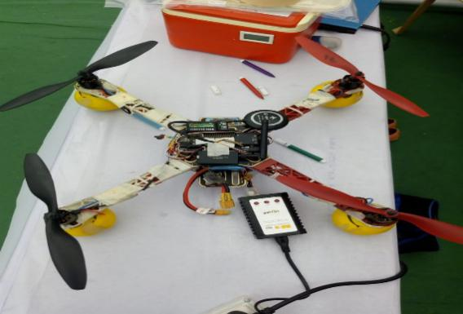 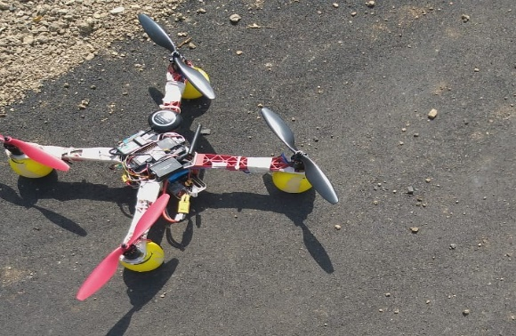

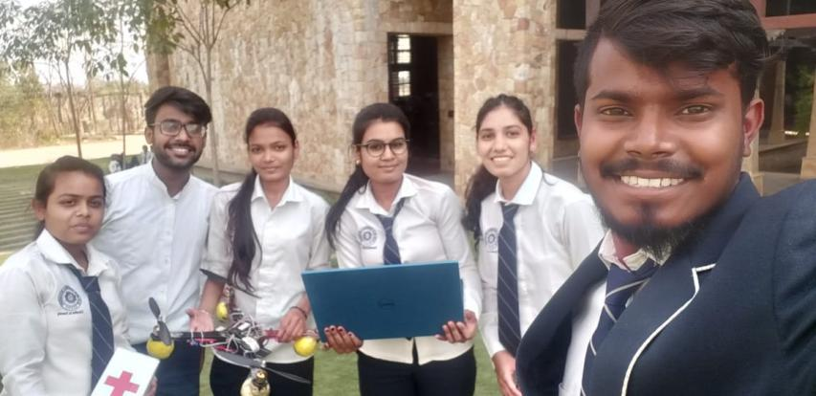

**Achievement:**

Our project selected in state level competition named as Dipex-2019 at Nanded held by Akhil Bhartiya Vidya Parishad (ABVP).

We won the first price under TECH-NIRMITI 2019 National level competition held in ABHA GAIKWAD-PATIL college of engineering at Nagpur.

Our paper published in 3rd International conference on I-SMAC 2019 (IoT in social, Mobile, Analytics and cloud) held at Tamilnadu.

**Implement Emergency Medical Facility Through Unmanned Aerial Vehicle**

Paper reference link: (<https://ieeexplore.ieee.org/document/9032642>)

**Conclusion:**

The currently available emergency medical services are not adequate for the rapidly growing world population given the ground transport difficulties due to traffic problems. Aerial medical services can reach the desired location a straight path saving time, cost and lives. Considering the ongoing rate of advancement in UAV technology and related safely systems, 24-hour quick medical help is poised to become a reality in the very near future. Such medical services will become a necessity soon and all efforts need to be taken to make them to make them a really as soon as possible. Our future goals for this project involve a multirotor aerial ambulance for rapid transport of patients from road mishaps, areas, affected by natural disasters, active war zone, etc.